1. 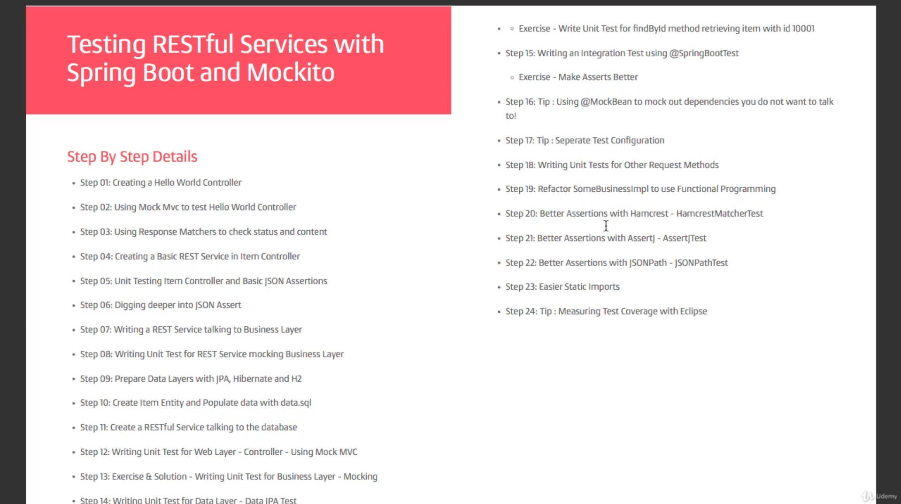
2. In a typical Web App, we have different layers (Web, Business, Data).   
   How do we write tests for each individual layers?  
   We will also see how **to write integration** tests combining all the layers together.